**Year 12 Essentials 2020**

**Test 2**

# Data Collection and Graphs

**Name:** _________________________________

Time for the task: 50 minutes

Resources allowed – Calculator, 1 A4 (one side) hand-written page of notes **Total Marks:** / 47

**Task weighting:** 8%

***Full working out must be shown to get full marks.***

***Attempt all questions in the space provided.***

|  |
| --- |
| **Question 1 [4 marks; 1 each]** |

Classify each of the following data collections according to whether they are a sample or census.

1. Favourite sports of secondary school students by surveying students in Year 10.
2. Number of hours spent completing homework each week by you class by surveying each student in your class.
3. Survey of all the customers leaving a sports shop between 10am and 11am to gauge customer satisfaction for that shop.
4. The most popular colours for cars sold in the last month in Western Australia, taken from the registration board database of all cars registered in the last month.

|  |
| --- |
| **Question 2 [9 marks; 3 each]** |

For each of the following investigations;

* State the population to be surveyed,
* Decide if a census or a sample should be used in collecting data.
* Give a reason for your answer.

1. Students opinions of the school uniform at Baldivis Secondary College.
2. Which venue should the year 12’s use for their school ball?
3. The most popular supermarket in Western Australia.

|  |
| --- |
| **Question 3 [2 marks; 1 each]** |

Give an example of how each of these sampling methods can be conducted.

1. Random sampling:
2. Systematic sampling:

|  |
| --- |
| **Question 4 [3 marks]** |

A survey was conducted to find the satisfaction rating of the service provided at a local café. The day of the survey coincided with a hailstorm which affected the area. The survey conducted was self-selecting and five people participated. All the participants were 100% satisfied with the service provided. Explain why this data is misleading and unreliable, give two reasons. Provide an example of how data could be collected in a more reliable manner.

|  |
| --- |
| **Question 5 [4 marks; 2 each]** |

Why are the following survey questions biased? Rewrite the question so that it is unbiased.

1. Do you agree that the school uniform at Baldivis Secondary College needs to be changed?
2. Rate how happy you are with the service received at the sports store:

□ Good □ Very Good □ Excellent

|  |
| --- |
| **Question 6 [4 marks; 2 each]** |

In what way are the following samples biased? How could you get an unbiased sample?

1. Asking people leaving a soccer match about their favourite sport?
2. Asking random people at the shopping centre what they think of the uniform at Baldivis Secondary College

|  |
| --- |
| **Question 7 [15 marks]** |

The table shows the linear relationship between the length of a mobile phone call and the cost of the call.

**BEBO INTERNATIONAL MOBILE PHONE PLAN**

|  |  |  |  |
| --- | --- | --- | --- |
| **Length of call (minutes)** | **1** | **2** | **3** |
| **Cost (dollars)** | **7.6** | **14.4** | **21.2** |

1. Draw the graph of the mobile phone plan on the axis below. **[2 marks]**

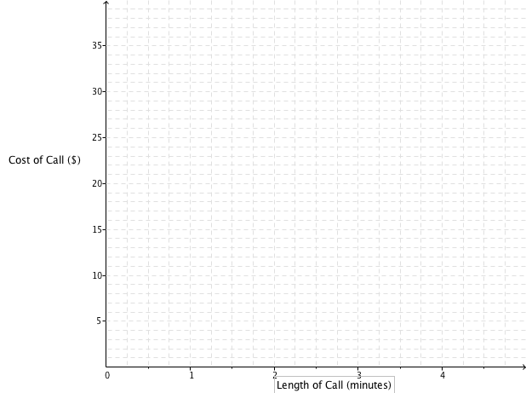

1. What is the cost of a 4-minute phone call on this BEBO phone plan? **[1 mark]**
2. What is the cost per minute for the BEBO phone calls? **[2 marks]**
3. What is the rule to calculate the cost (c) of a phone call of (m) minutes on the BEBO phone plan?

**[3 marks]**

1. GINTS international phone plan uses the formula c = 3.4m + 11. Draw this on the axis above.

**[3 marks]**

1. Which mobile plan is better if I plan to make a phone call of 1.5 minutes? How much better would it be? **[2 marks]**
2. What length of call are the two phone plans the same cost? What is the cost at this time? **[2 marks]**

|  |
| --- |
| **Question 8 [6 marks; 3 each]** |

Paul owns a factory that makes sails. It costs $9000 per month to cover rent, electricity and wages in the factory. Each sail costs $250 to make and sells for $850.

1. How many sails does Paul need to make and sell per month to break even?



1. What profit or loss will he make in a month if he makes and sells 20 sails?

**End of Test**